Lesson 10
Polar Coordinates

Specific Objectives

At the end of the lesson, the student is expected to be able to:
- define polar coordinates.
- plot points polar coordinates.
- write and sketch the graphs of polar equations.
- convert polar to rectangular and vice versa.

10. 1 THE POLAR COORDINATE SYSTEM

Definition 10.1

The Polar Coordinates System is a coordinate system in which the coordinates of a point in a plane are its distances from a fixed point and its direction from a fixed line. The fixed point is called the origin or the pole and the fixed line is called the polar axis. The coordinates given in this way are called Polar Coordinates.

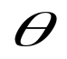
r
O
A
P(r,
)
Figure 10.1.1

Where: O – origin or pole
OA – polar axis
r – radius vector
- polar angle
P(r, ) - polar coordinates

Remarks: Sign Conventions:
For Polar Angle () :
- Positive (+) – if it is measured counterclockwise from the polar axis.
- Negative (-) – if it is measured clockwise from the polar axis.

For radius vector ( r ) :
- Positive (+) – if it is measured from the pole along the terminal side of polar angle ().
- Negative (-) - if it is measured along the terminal side extended through the pole.

Example 10.1. Plot the given points on a polar coordinate system.
3
45º
O
A
P(3,
)
- P(3, 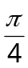)

Figure 10.1.2

- P(3, -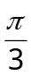)
3
-60º
O
A
P(3, -
)

Figure 10.1.3

- P(-3, 220º)
3
-3
220º
O
A
P(-3, 220º)
Figure 10.1.4

- P(-3, -75º)

3
-3
-75º
O
A
P(-3, -75º)
Figure 10.1.5

Exercise 10.1.1 Plot the given points on a polar coordinate system.

1. P(4, -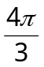)
2. P(-2, -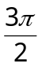)
3. P(4, 30º)
4. P(-5, 300º)
5. P(-1, 180º)

Exercise 10.1.2 Identify each point (r, ) provided that r0 and 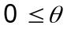< 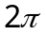.

E
C
B
(4, 0)
A
D

Figure 10.1.6

10.2 RELATIONS BETWEEN RECTANGULAR AND POLAR COORDINATES

The transformation formulas that express the relationship between rectangular coordinates and polar coordinates of a point are as follows:

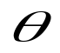
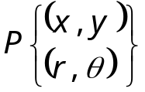
x
y
r
O
y-axis
x-axis
polar axis

Figure 10.2.1

cos = 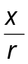 and sin = 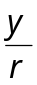

x = r cos y = r sin

Also,
r² = x² + y² 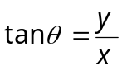
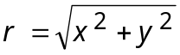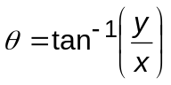

Example 10.2.1 Find the rectangular coordinates of the following polar coordinates.

- (-6, 150º ) Ans. (3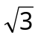, -3)
- (-3, ) Ans. (0, 3)
- (4, 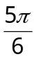) Ans. (-2, 2)
- (6, ) Ans. (-6, 0)
- (3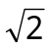, 225º ) Ans. (-3, -3)
Example 10.2.2 Find the polar coordinates of the following rectangular coordinates.

- (0, -5) Ans. (5, 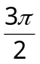)
- (4, 4) Ans. (4, 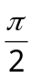)
- (, -1) Ans. (2, 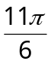)
- (-5, -12) Ans. (13, 4.31 rad)
- (-, -) Ans. (2, 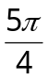)

Exercise 10.2.1 Find the rectangular coordinates of the following polar coordinates.

- (-5, 120º ) Ans. 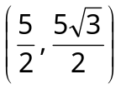
- (1, -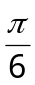) Ans. 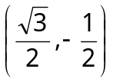
- (-3, -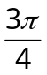) Ans. 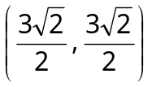
- (4, 330º ) Ans. 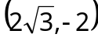
- (2, 270º) Ans. 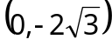

Exercise 10.2.2 Find the polar coordinates of the following rectangular coordinates.

- (0, -3) Ans. 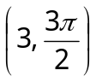
- (-2, 4) Ans. (2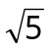, 116.57⁰ )
- (3, ) Ans. 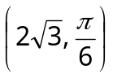
- (5, 13) Ans. (13.93, 248.96⁰ )
- (, -) Ans. (5, 135⁰ )

10.3 POLAR EQUATIONS
Definition 10.3 Polar Equations

Polar equation is an equation in terms of r and .

Note: The formulas given in Definition 10.2 will be used in transforming rectangular equation to polar equation and vice-versa.

Example 10.3.1 Transform the following equations into the corresponding polar coordinate equations.

- y = 4 Ans. 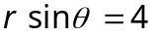
- 3x – y = 0 Ans. 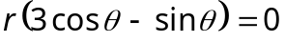
- x² = 4y Ans. 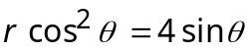
- x² – 2y² = 4 Ans. 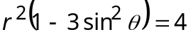
- x² + y² = 9 Ans. r = 3

Example 10.3.2 Transform the following equations into the corresponding rectangular coordinate equations.

- r = 4 Ans. x² + y² = 16
- 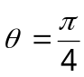 Ans. y = x
- rcos= 4 Ans. x = 4
- r = 8cos Ans. x² – 8x + y² = 0
- 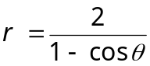 Ans. y² = 4 (x + 1)

Exercise 10.3.1 Transform the following equations into the corresponding polar coordinate equations.

- y = -5 Ans. r sin + 5 = 0
- y² = 9x Ans. r sin² = 9 cos
- 2x² + y² = 3 Ans. 2r² = 3
- x² - 9y = 0 Ans. rcos² = 9 sin
- x² + y² = 2y Ans. r = 2 sin

Exercise 10.3.2 Transform the following equations into the corresponding rectangular coordinate equations.

- r = 6cos Ans. x² + y² = 6x
- rsin= 4 Ans. y = 4
- r²sin 2 = a² Ans. 2xy = a²
- 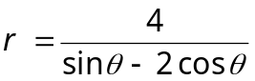 Ans. y – 2x = 4
- 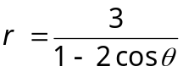 Ans. y² – 3x² = 12x + 9

10.4 GRAPH OF A POLAR EQUATION
Definition 10.4 Graph of a Polar Equation

The graph of an equation r = f() in polar coordinates is the set of all points (r, ) whose coordinates satisfy the equation.

Example 10.4.1 Trace r = 1 + 2 cos.

 | 0º | 30º | 60º | 90º | 120º | 150º | 180º | 210º | 240º | 270º | 300º | 330º | 360º
cos | 1 | 0.87 | 0.5 | 0 | -0.5 | -0.87 | -1 | -0.87 | -0.5 | 0 | 0.5 | 0.87 | 1
2cos | 2 | 1.73 | 1 | 0 | -1 | -1.73 | -2 | -1.73 | -1 | 0 | 1 | 1.73 | 2
r | 3 | 2.73 | 2 | 1 | 0 | -0.73 | -1 | -0.73 | 0 | 1 | 2 | 2.73 | 3
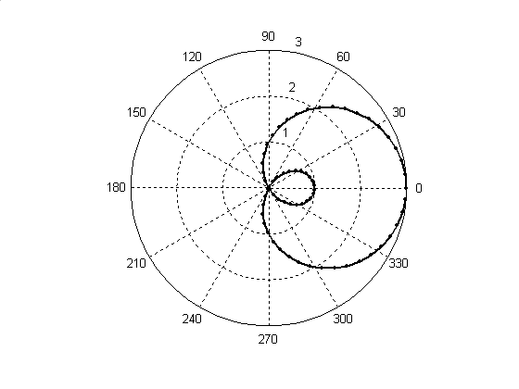 Figure 10.4.1

Exercise 10.4.1 Construct the graph of the following equations.
- r = 4
- r = 3 + sin
- r = 4 - cos
- r = -3 cos
- r = -2 sin
10.5 SPECIAL TYPES OF POLAR CURVES

Definition 10.5 Special Types of Polar Curves

- Rose Curve
r = a sin nθ or r = a cos nθ if n is odd, there are n leaves; if n is even there are 2n leaves
- Limacon
r = b + a sin θ or r = b + a cos θ if a = b, the limacon is called a cardiod; if |b| > |a| , the graph is a curve surrounding the origin; if |b| < |a|, the graph has an inner loop
- Lemniscate
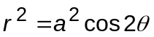 or 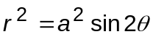
- Spirals
r = aθ Spiral of Archimedes
rθ = a Reciprocal or Hyperbolic Spiral
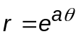 Logarithmic Spiral

The following are some special types of polar curves:
Fig. 10.5.1 Cardiod
Fig. 10.5.2 Limacon

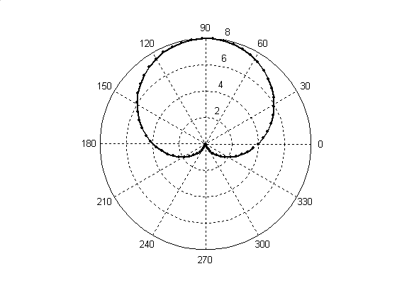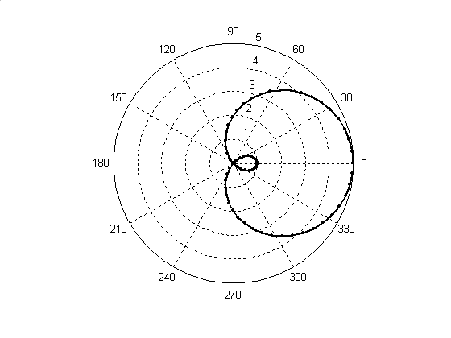

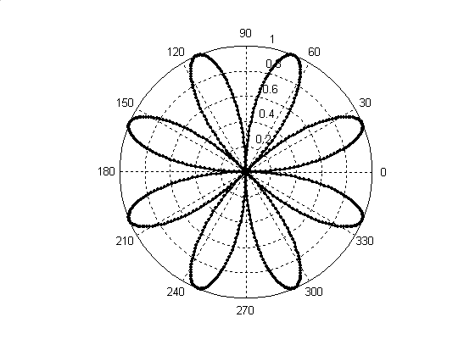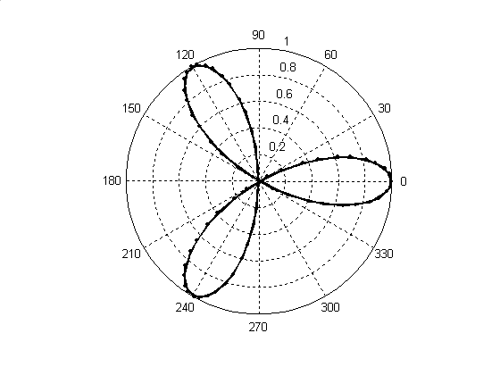
Fig. 10.5.3 Eight-Leaf Rose
Fig. 10.5.4 Three-Leaf Rose

Fig. 10.5.6 Logarithmic Spiral
Fig. 10.5.5 Spiral of Archimedes

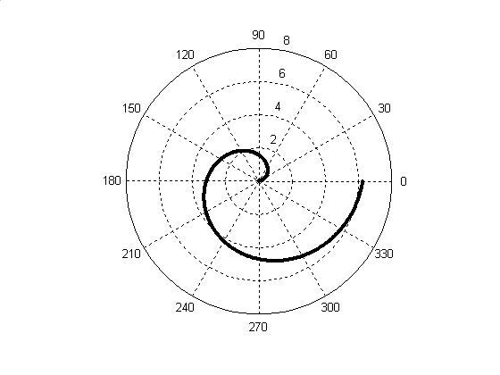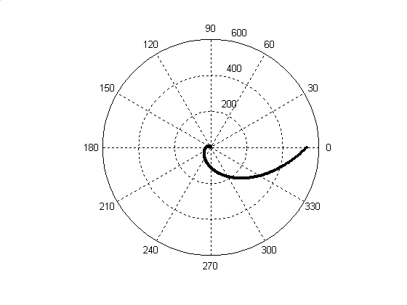
Fig. 10.5.7 Lemniscate

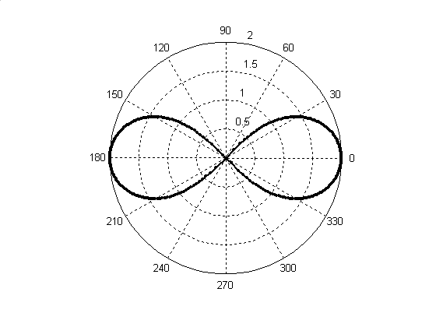

Example 10.5.1 Given the equation, identify the type of the following polar curves without sketching the graph:

- r = 4(1 + sinθ)
- r = 2 cos 3θ
- r² = 25 cos 2θ
- r = 3 + 6 cosθ

